HKU-BICI Entrepreneurship Joint Educational Placement Programme
香港大学-北京协同创新研究院创新创业博士项目

FAQs for applicants
常见问题（申请人）

- Who should apply?
谁适合申请本项目？

The HKU-BICI Entrepreneurship Joint Educational Placement Programme for PhD is suitable for those who wish to pursue forward looking research and to transfer fundamental scientific and technological achievements into real productive forces.

If you are interested in participating in practical entrepreneurship training and developing your research commercialisation skills in one of our five key research areas, namely optoelectronics, materials, environment engineering, biomedical engineering and intelligent manufacturing, this is your chance to enter an excellent network of top scientists in different disciplines contributing to solving real-world problems and making positive impact to the world.

香港大学-北京协同创新研究院创新创业博士项目（以下简称“本项目”）旨在培养具有开阔的全球视野、突出的创新精神、深厚的专业知识和优秀的专业技能，能创造性地解决复杂实际问题的创新创业高端人才。
围绕我们的五个关键研究领域，即光电技术、材料与化工、环境与资源、生物医学工程和智能制造，我们希望您有志于推动科学向技术转化。

- Am I eligible for this programme?
本项目遴选及录取标准？

Applicants should meet the minimum admission requirements of both HKU and BICI. Prospective students will be assessed through a joint selection process and shall be recruited jointly by HKU and BICI. Please click here for admission requirements of HKU; and here for admission requirements of BICI.

申请人须符合港大和协同院的最低入学要求，并通过双方的联合选拔程序。港大的入学要求可参考官网，协同院对符合港大录取资格的申请者进行创新能力考核。

- What is the difference between the traditional PhD training and the entrepreneurship training offered by this programme?
本项目与传统的博士项目相比有何区别？

Traditional PhD training requires students to undertake independent research to produce original ideas with significant impact, while the HKU-BICI Joint Programme engages the students in both scientific research and practical entrepreneurship training on real-world projects to develop their entrepreneurial spirit, creative thinking, research commercialisation skills, professional knowledge and expertise.

Admitted students are expected to spend 2 years at HKU (1st-18th months and 43rd-48th months), and 2 years at BICI (19th-42nd months). Students will follow the regulations and procedures of the PhD programme at HKU including coursework requirement, progress monitoring, etc, and take innovation and entrepreneurship courses and receive practical project-based training offered by BICI at its research centres in Beijing or Guangzhou together with peers across universities and disciplines.

The below diagram outlines the programme’s unique dual-track training model. Click here to learn more about BICI’s innovation and entrepreneurship course.

传统的博士项目侧重要求学生进行独立研究，以产生具有重大影响的原创想法。
本项目采取双课堂、双导师、双身份、双考核“四双”模式（如示意图）联合培养创新型学生，学生在港大学习专业理论课，在协同院学习创新创业课和以真实项目为基础组队进行创新创业训练，由港大导师、协同院创新导师联合指导，学生参照全职人员获取报酬并分享成果转化收益，在理论成绩与实战效果达标后授予学位。本项目课程设置等可参考官网。
本项目录取学生在港大和协同院学习时间各半，常规安排为首18个月在港大就读，其后24个月在协同院或协同院指定的项目地点接受培养（一般安排在北京或广州），最后6个月在港大就读。
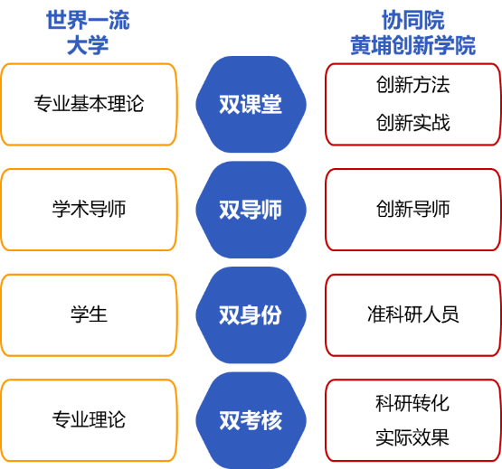

- What is the language requirement?
本项目的语言要求？

Applicants should be proficient in Chinese and English communication and writing.

An applicant who is seeking admission on the basis of a qualification from a university or comparable institution outside Hong Kong of which the language of teaching and/or examination is not English is required to submit English Language Proficiency Test results. Please click here for the details.

申请人应精通中英文交流和写作。
申请人如以香港以外的大学或相类院校的学历申请入学，而该等院校的教学及／或考试语言并非英文，则须提交英文语言能力测验成绩。详细要求可参考港大官网。

- What supporting documents do I need to submit?
我需要提交哪些证明文件/支撑材料？

Please click here to check the supporting documents needed. Applicants to the HKU-BICI Joint Programme should also complete (i) an additional Application Form in simplified Chinese, (ii) a Study Plan in consultation with their intended supervisors and (iii) a Chinese CV.

If some of the required supporting documents are not available at the time of submission, please upload the documents to the Online Application System once the document is available. The reviewer(s) will consider your application based on the documents submitted and it is your responsibility to provide sufficient information.

请点击此处查看所需的证明文件。本项目申请人还应（1）以简体中文填写项目申请表，（2）在与双方意向导师充分沟通后以英文填写博士期间学习计划，以及提交（3）一份中文简历。
如果部分所需的证明文件在提交网上申请时尚未准备好，请在文件准备就绪后及时上传到港大在线申请系统。审核人员将根据提交的文件考虑您的申请，您有责任提供足够的信息。

- How can I find my supervisors?
我如何寻找导师？

Interested applicants should contact their proposed supervisor at HKU and obtain his/her consent in advance before submitting an online application. You may look for supervisors from the HKU Scholars Hub. A list of supervisors from the BICI can be found at the BICI website, you may share this link with your proposed supervisors at HKU for their consideration.

有意申请者应在提交网上申请前，与港大意向导师联络，并事先征得其同意。您可以从此处寻找港大意向导师。协同院创新导师信息可参考官网，您可以将此链接分享给您在港大的意向导师，供其考虑。

- When is the application deadline?
本项目申请截止时间？

This programme is open for application all year round and considered in batches. In view of the limited admission quota, applicants are strongly encouraged to apply in the Main Round as far as possible. Applications will be considered in the clearing rounds only if there are vacancies after the Main Round. Please click here for the application period in the latest round.

本项目常年接收申请，分批次受理。鉴于每学年的录取名额有限，我们强烈鼓励申请人尽早申请。请点击此处查看最新一轮的申请期限。

- Do I need to apply separately to the discipline in which I am interested as well as to this joint programme?
我是否需要单独申报感兴趣的学科和本项目？

No. You only need to go through the application process for admission to this joint programme. In the online application form under “Section 1: Programme Apply For”, please specify that you would like to be considered for the “HKU-BICI Entrepreneurship Joint Educational Placement Programme for PhD”. If you are admitted into this joint programme, you are also admitted into the discipline you selected.

您只需要通过港大在线申请系统提交本项目的申请。在“Section 1: Programme Apply For”中，请注明您希望参加香港大学-北京协同创新研究院创新创业博士项目的选拔。如果您被本项目录取，您也会同时被您选择的学科录取。

- When will I get the result notification?
我何时能获悉录取结果？

The Graduate School will inform all applicants of the result of their applications in writing in about three to four months after the closing date of application. Applicants may also check the result via the Online Application System.

港大研究学院将在申请截止日期后约三至四个月内将申请结果以书面形式通知所有申请人。申请人也可以通过在线申请系统查看结果。

- What kind of funding will be available to me?
本项目奖助支持？

Students admitted to this joint programme will receive scholarships for up to four years provided by BICI. During the student’s study period in HKU in Hong Kong, students will receive scholarships in accordance with the standard HKU Postgraduate Scholarship (PGS) rate. During the residency at BICI or BICI’s designated project locations, the scholarships will be granted by BICI in accordance with its regulation and policies (up to RMB 20,000 per month).

协同院为本项目录取学生提供最高4年的奖学金资助。其中，在港大学习期间，协同院将按照港大博士生标准（PGS）提供奖学金（作为参考，2023-24学年港大博士生奖学金标准（PGS）为每人每月港币18,890元）。在协同院学习期间，协同院将按照相关制度评定和发放奖学金（每人每月最高人民币20,000元）。

- Can I re-apply if I was not selected in the previous round?
如果在前序轮次中未获录取，我是否可以再次申请本项目？

Applicants only need to submit once for each academic year. If your application was unsuccessful in the previous academic year, you may re-apply in the new academic year by submitting a new application via the Online Application System including full set of supporting documents and pay the application fee for each new application.

申请人每学年只需要提交一次在线申请。如果您在上一学年的申请不成功，您可以在新学年重新申请，您需要通过港大在线申请系统提交一份新申请，包括全套证明文件，并支付每份新申请的申请费。

